**External Tool Instructions for the Stage Builder Application:**

**Overview:**

This Stage Builder application is supposed to help anyone editing any stage for the production of the game “Blank Canvas”. If you are designing a stage for the game this is the tool you will use to create a stage. There are some nice features about the Stage Builder Application including the ability to load and edit any stage that has been previously worked on in the bin and a nice key for text characters that build different objects in the stage.

**Important Information about the key:**

* If you see a “**#**”symbol in the key it must be replaced with a number between 0-9. Any other assets with the same number placed before it will be linked. For example a red orb “1R” can be linked with a door “1/” so that you must turn the red orb red unlock the door.
* The dimensions of all assets are given in the key. The dimensions are given in square brackets: **[Width of Asset x Height of Asset].** If the height is greater than 1 the asset will be built from the bottom up (this means when you place the player character spawn in the stage file you must put the player character (P) on a spot right above the ground).
* You must have only one “P” in a stage. This represents the spawn for the player character.

**How to Create a Stage in the Stage Builder Application**

**Step 1: Enter a Stage Name and Level Number**

When you start the application the first thing you must do is enter a stage name. This can be a pre-existing stage name or an entirely new stage name. You can also enter the level number for the stage.

**Step 2: Hit the “Load File” Button**

After entering the stage name and the level number you should hit the load file button to continue. This loads in any existing text file that has previously been built into the text editor box. This prevents someone from writing over a previously worked on stage. If a level with the same name has not been created yet then the text box will remain blank.

**Step 3: Edit or Create the Stage in the Text Box**

Using the character key on the left and the text box to the right you can edit or create a stage. After you finished designing a stage in the text box it should look something like this:

Example of a stage made in the stage builder:

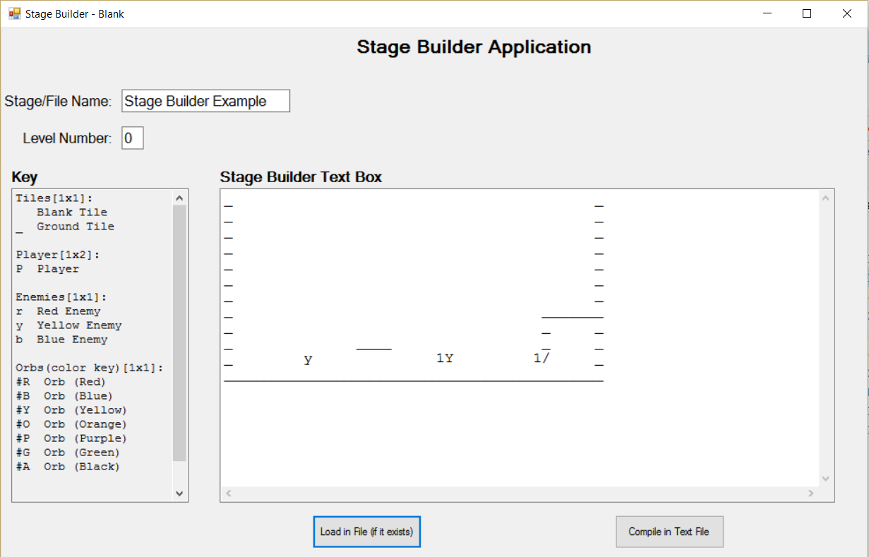

**Step 4: Saving your edits or saving your new stage**

After you edit your stage to your heart’s desire, hit the “Compile in Text File” button. This will save all of your edits or create a new stage file (using the Stage Name typed earlier). Now you have a newly edited or created stage file!